# Source Control Screenshot(S1)

Link: <https://github.com/profiteroles/RAD>

Screenshot:

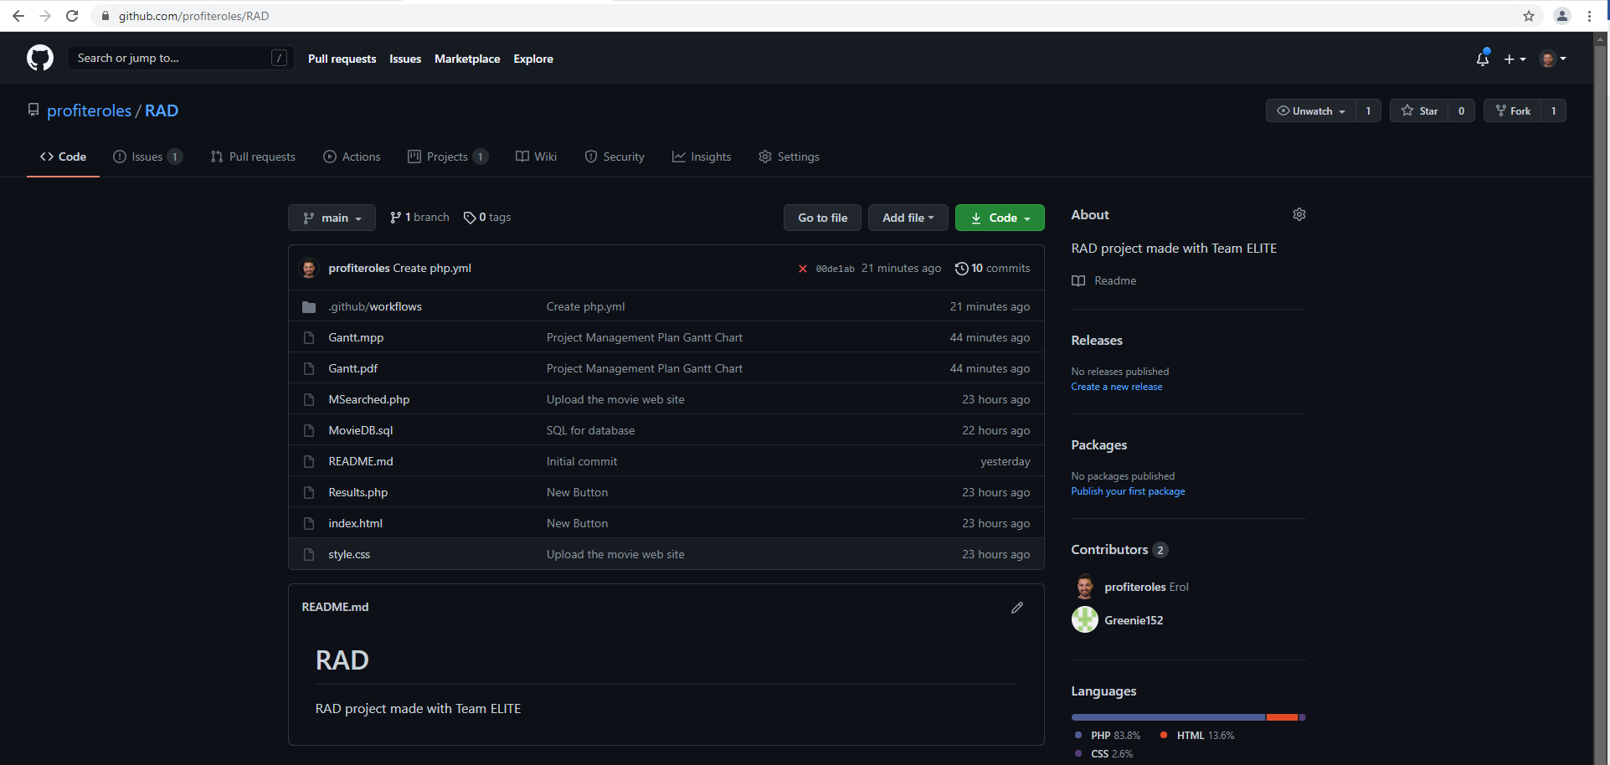

Figure 1- GitHub Screenshot

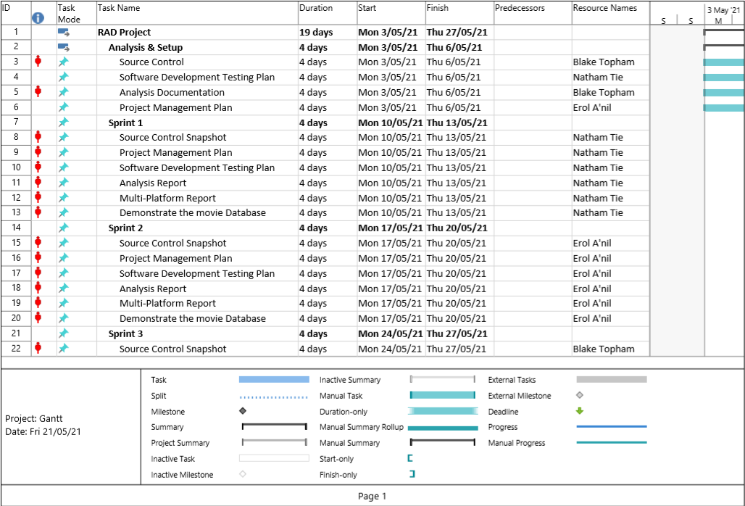

Figure 2- GANTT Chart

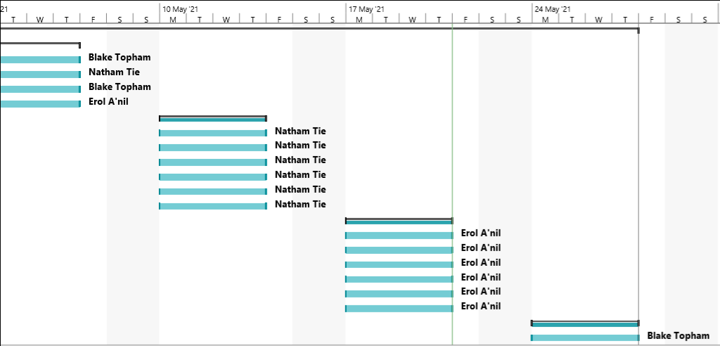

Figure 3- GANTT Chart (continued)